KV32HS500, KV32HS510, KV32HV600, KV34HS510, KV34XBR800, KV36HS500, KV36HS510, KV36XBR800, KV40XBR800
Subject
CRT socket P/N missing

SYMPTOMS
The part number for J9001 the CRT socket on the CX board is missing from the service manual.
RESOLUTION
The part number is 1-451-544-11.

KV32HS500, KV32HV600, KV34XBR800, KV36HS500, KV36XBR800, KV40XBR800
Subject
Bad Purity, not CRT

SYMPTOMS
Picture had bad purity distortion. Replaced CRT same problem.
RESOLUTION
Found bad connections on the W Board. W Board replaced.
Best way to troubleshoot is to remove CN9100 & CN9102
SUPPORTING GRAPHICS
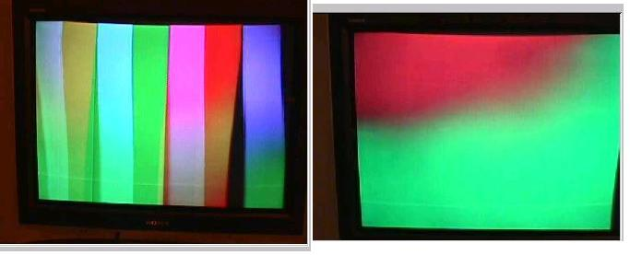
Parts
Part Number | Reference Number | Description | Symptom Code | Section Code | PCB Reference | Defect Code | Repair Code
A1400561A | 45 | W Board | 1434 | DFL | W | A | A

KV32HS500, KV32HV600, KV34XBR800, KV36HS500, KV36XBR800, KV40XBR800
Subject
Closed Caption not working

SYMPTOMS
Closed Caption not working with local channels does work with the national channels. Other sets in home work, tried other CC modes same problem
CAUSE
Install circuit board mounting rail extenders that improve the A-board's reliability during handling of the TV. DESCRIPTION PART NUMBER RAIL EXTENDER KIT T-998-607-37 PVC PIPE GLUE PURCHASE LOCALLY* *Premier's Plastic Pipe Cement for PVC pipe and low-pressure sprinklers is one example of this type of glue. The following references to left-side and right-side mean as the set is viewed from the front. Procedure: 1- Remove rear cabinet. 2- Remove A-board. 3- Identify the left-side and right-side rail extenders (see illustration # 2).
RESOLUTION
- Does CC work for the sub picture?
If so, there might be something wrong with the main tuner.
- How is the signal level for the local channels?
If the signal level is too low, the tuners will not be able to see the CC info.
The CCD category in service mode does control CC decoding.
This data might have been corrupted. Check the data against the ones listed in the Service Data List, under CCD Category.

KV32HS500, KV32HV600, KV34XBR800, KV36HS500, KV36XBR800, KV40XBR800
Subject
S Board has no schematic or listed in the Parts List.

SYMPTOMS
The block diagram show S Board but no breakdown schematic and also not in the parts list.
CAUSE
The correct P/N is X-403-763-13.
RESOLUTION
The schematic is correct, only the block is outdated. The block was a preliminary one we received from engineering. Component IC2501 on the S board were integrated into the M Board when the design was finalized.
The schematics are correct. See page 236 M Board 4/4
The Block will be updated.

KV32HS500, KV32HV600, KV34XBR800, KV36HS500, KV36XBR800, KV40XBR800
Subject
No audio from the Audio Out (VAR/FIX)

SYMPTOMS
Customer is connecting a HiDef cable box to Video 6 component & audio left & right. The customer turns off internal speakers and fixed the output so he can have the audio go to the headphones. With this connect gets no audio from the Audio Out (VAR/FIX). However when using the other composite inputs, there is sound that comes out fix var outs. Question is the Fix/Varible outs disable in using video 6 & 7.
RESOLUTION
The Audio Out (VAR/ FIX ) should works in using Video 5, 6 & 7 in all DA-4 chassis models.
In the case of the Customer's TV set , I think that the problem is related with the IC 2501 Audio processor circuit (TC94A04AF-014) on [M] board , this device receives video 5 and video 6 audio inputs (Pin 46, 47(Left) ,50, 51 (Right)), process them and send the outputs through Pin 8, 10 to the IC2502 Audio Buff (IC2502).

KV32HS500, KV32HV600, KV36HS500
Subject
Removal and installation of front panel control door.

SYMPTOMS
The method for removing and installing the front panel control door is not shown in the service manual.
RESOLUTION
To remove the door, refer to attached files named Removal step 1.jpg and Removal step 2.jpg.
To install the door, refer to attached files named Install step 1.jpg, Install steps 2 - 4.jpg, and Install step 5.jpg.
Removal step 1
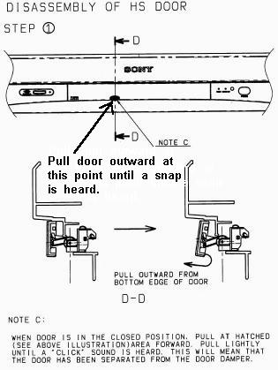
Removal step 2

Install step 1
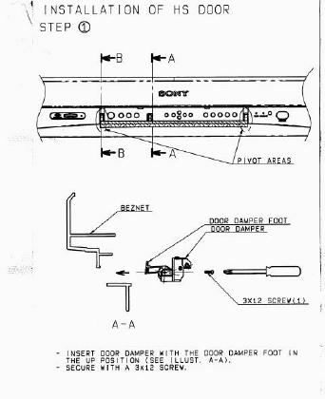
Install steps 2 – 4
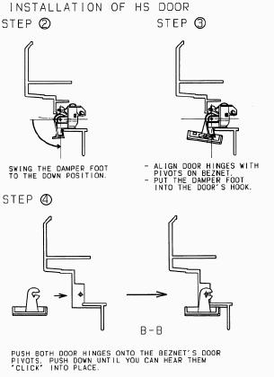

Install step 5
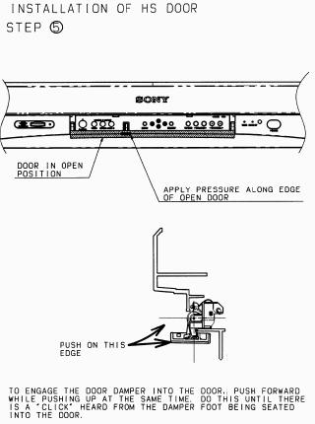

KP57WV600, KP57WV700, KP65WV600, KP65WV700, KV32HS500, KV32HV600, KV34XBR800, KV36HS500, KV36XBR800, KV40XBR800
Subject
TV won't display Memory Stick pictures, ''File Error'' appears on the screen.

SYMPTOMS
The TV won't display pictures stored on a Memory Stick. ''File Error'' appears when trying to view the pictures.
CAUSE
This will occur if the directory structure on the Memory Stick is not DCF compliant (DCF is an abbreviation for Design rules for Camera File systems). The error can also appear if the picture file names have been changed, or if the picture files have been edited.
RESOLUTION
Refer the customer to the Memory Stick section of the owner's manual, or the Memory Stick supplement packaged with the TV, for instructions on the proper use of Memory Stick files and directories.
See the attached file ''Memory Stick Supplement Sample'' for details related to the direct view models; rear projection models are similar.
NOTE: The new PRO memory stick will not work with current sets.
SUPPORTING DOCUMENTS AND GRAPHICS
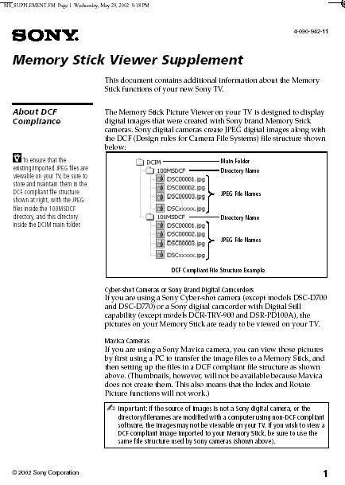

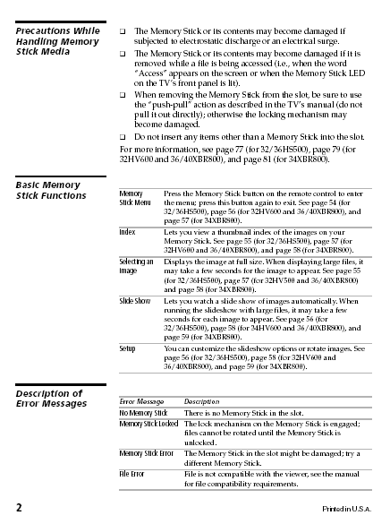

KV32HS500, KV32HV600
Subject
Incorrect warranty information packaged with TV.

SYMPTOMS
Early production sets included the warranty card for 2001 model year XBR models (1 year part and labor), but these models are covered under the standard warranty (1 year parts, 90 days labor).
RESOLUTION
The labor for KV-32HS500 sets up to and including serial number 8013628, and for KV-32HV700 sets up to and including 8002878, can be covered for a period up to 1 year from the date of original purchase.

KV32HS500, KV32HV600, KV34XBR800, KV36HS500, KV36XBR800, KV40XBR800
Subject
60 Hz bars through the picture

SYMPTOMS
60 Hz bars through the picture. The bars disappear when the rear cover is removed.
RESOLUTION
Found the problem to be caused by the upper degaussing coil pinched to shield, from the pressure of the rear cabinet.
Remounted the coil to avoid being caught by the rear cabinet.

KP51WS500, KP57WS500, KP57WV600, KP57WV700, KP65WS500, KP65WV600, KP65WV700, KP65WV700, KV32HS500, KV32HV600, KV34XBR800, KV36HS500, KV36XBR800, KV40XBR800, SATHD200
Subject
No picture when using DVI, not able to pick the best video format

SYMPTOMS
Set might not display picture when hooked up to a STB with DVI output. Or if picture is displayed, STB will not be able to automatically pick the best video format to output to set.
As an example, for the SAT-HD200 (Sony's DirecTV/HD Receiver with DVI functionality) the customer issue is that the box will not be able to operate in Auto-DVI mode.
CAUSE
Missing EDID data.
The UD Board contains the timing preference for the signal received from the STB.
RESOLUTION
Replace the UD Board.
10/10/02 UD Boards in WRPC were placed on hold so they could have the software for the NVM updated. They should be available soon.
For this issue only, the warranty will be extended 2 years after the standard warranty period.

KP57WV600, KP57WV700, KP65WV600, KP65WV700, KV32HS500, KV32HV600, KV34XBR800, KV36HS500, KV36XBR800, KV40XBR800
Subject
Memory slot P/N missing

SYMPTOMS
Need the P/N for the memory slot which is not in the SM.
RESOLUTION
The memory slot is a complete assembly it's P/N is 1-816-402-11.
It is listed as Connector, Memory stick Ref CN7201.
The door is not a replaceable item as such.
Order the CN7201 connector.
On the Direct View models it's listed on the HM Board Ref CN7201.
Part Number | Reference Number | Description | Symptom Code | Section Code | PCB Reference | Defect Code | Repair Code
181640211 | CN7201 | Connector, Memory stick | 118X | INC | NONE | A | A

KV32HS500, KV32HV600, KV34XBR800, KV36HS500, KV36XBR800, KV40XBR800
Subject
Moving vertical bar while viewing 1080i

SYMPTOMS
Vertical bar moving from right to left. The bar is about 4 to 5 inches wide and goes from right to left across the screen every second. This can be most easily seen in the standard or vivid picture mode. It's also more pronounced when brightness is increased. Happens with either DVI or Component input.
CAUSE
B Board A1300-327-A Use in models:
KV-32HV600, KV-34XBR800, KV-36XBR800, and KV-40XBR800.
B Board A-1300-327-A used in models:
KV-32HS500, KV-36HS500
RESOLUTION
The video path for 1080i will be changed.
Make sure the B Board has the components on the attached list. If not there replace the B Board.
Apply the data changes as per the attached list.
NOTE:
1. Most sets in the market will already have these parts mounted. Models produced between October through December 2002 might not have these parts.
2. Units with the parts mounted just need to change the Service Mode settings.
3. Boards in WRPC have these parts mounted. The part list attached gives the list of components that must be on the board and should be used as a reference. If the parts are missing then the board should be replace. Adding the components to the B Board should not be attempted.
4. NVM (IC3089) of the defective [B] board should be transfered to the new [B] board.
5. Check to see if IC-3414 is mounted under the shield cover component side of board. If there then you have the correct board with all components.
SUPPORTING DOCUMENTS AND GRAPHICS
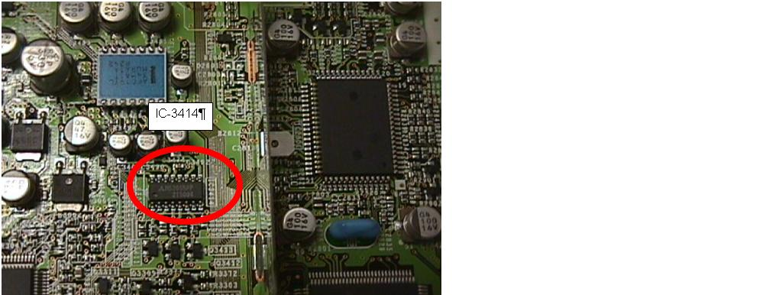

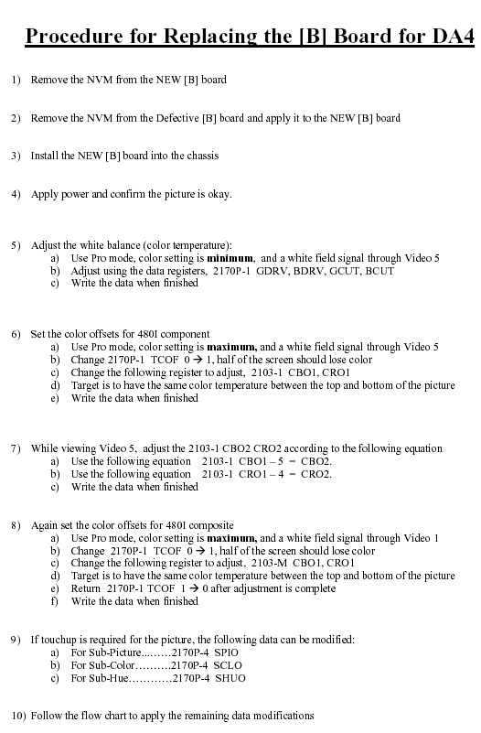

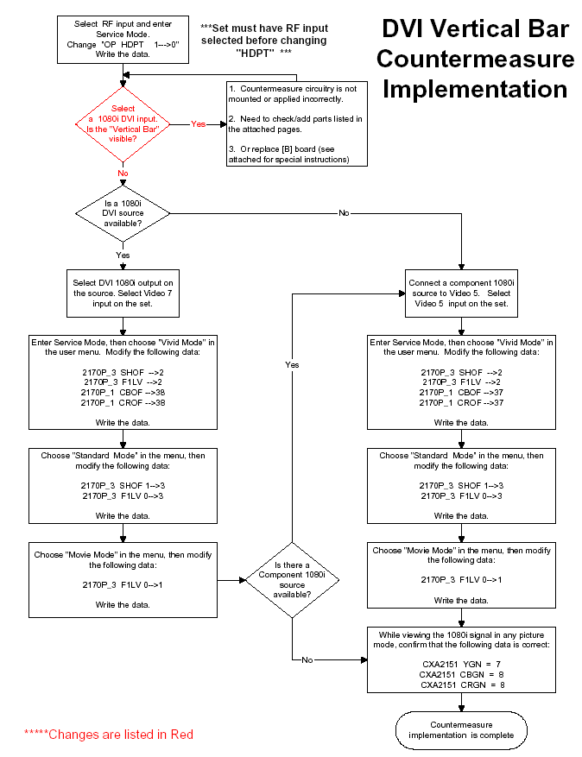

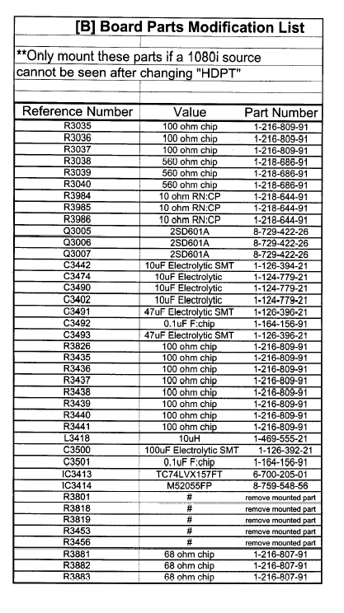

KV32HS500, KV32HV600, KV34XBR800, KV36HS500, KV36XBR800, KV40XBR800
Subject
M Board P/N correction

SYMPTOMS
M Board P/N is not correct on page 295 of the S/M.
RESOLUTION
The correct P/N is A-1300-320-A
This was covered in S/M Correction-1
SUPPORTING DOCUMENTS AND GRAPHICS
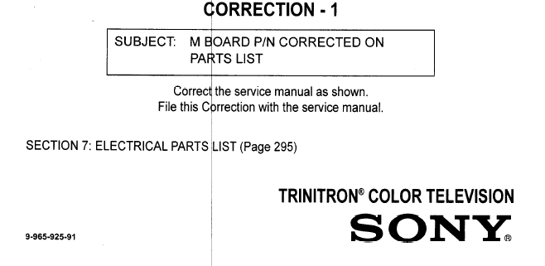
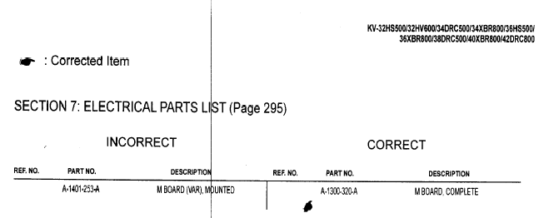

KV32HS500, KV32HV600, KV34XBR800, KV36HS500, KV36XBR800, KV40XBR800
Subject
Unit making crackling and popping noise

SYMPTOMS
Customer complaint the unit make crackling and popping noise ! After 1 hour in the customer home I found out it just a squeezing noise from the TV cabinet when the temperature changed from hot to cold the plastic cabinet expands
RESOLUTION
Tech reported that he squeezes the two top corners of the Bezel and while squeezing moves each corner in the opposite direction at the same time. You will hear the cabinet make noise keep doing this procedure to the cabinet noise stops.

KV32HS500
Subject
NS coil connection

SYMPTOMS
Found cable coming from PC board mounted to the yoke disconnected. Where does this connector go?
Where does the connector for the NS coil connect on the HS model ?
RESOLUTION
Should connect to CN9101 on W Board.

KV32HS500, KV36HS500
Subject
What is the correct part number for the B Board

SYMPTOMS
What is the correct part number for the B Board
RESOLUTION
SM part number for the B Board was revised.
The correct P/N for the B Board is:
A-1300-325-A
For models KV-32HS500, KV-36HS500 ONLY

Model KV32HS500: Features

FD TRINITRON PICTURE TUBE
HI SCAN 1080I CHASSIS
DRC MULTI-FUNCTION(961I & 480P)
CINEMOTION REVERSE 3-2 PULLDOWN
FLEXIBLE TWIN-VIEW TWO TUNER PICTURE-AND-PICTURE
MID X (MULTI-IMAGE DRIVER X) CIRCUITRY
MEMORY STICK MEDIA STILL IMAGE PLAYBACK
"ARC" SHAPED DESIGN
CLEAR EDGE VM WIDEBAND VELOCITY MODULATION
2 HD CAPABLE COMPONENT VIDEO INPUTS (Y/PB/PR)
720P INOUT CAPABLE (1080I CONVERSION)
3D DIGITAL COMB FILTER
AUTO 16:9 ENHANCED MODE
ID-1 DETECTION (480P)
TRUSURROUND SOUND (7.5W X 2)
15W SUBWOOFER
FRONT: A/V INPUT WITH S-VIDEO
REAR:
COMPONENT VIDEO INPUT (2HD CAPABLE)
COMPOSITE VIDEO INPUT (3)
S-VIDEO INPUT (2)
AUDIO OUTPUT (FIXED/VARIABLE)
DUAL RF INPUTS
DVI--HDTV INTERFACE

Model KV32HS500: Specifications

DIMENSION | 35 3/8 X 27 1/8 X 24"
WEIGHT | 176 LBS 8 OZ
COMPONENT VIDEO | 2 REAR HD
COMPOSITE INPUT | 3 REAR/1 FRONT
SVIDEO INPUT | 2 REAR/1 FRONT
RF INPUT | 2 REAR
ENERGY STAR COM | YES
MONITOR OUT | 1 REAR

KV32HV600, KV34XBR800, KV36XBR800, KV40XBR800
Subject
Red tints when in HD mode

SYMPTOMS
Red tints when in High Definition mode and regular TV pixelized
RESOLUTION
On HD up-close shots of people they look like everybody had bad sunburn. The reds were blooming.
Replacing the B Board solved the problem.
SUPPORTING GRAPHICS
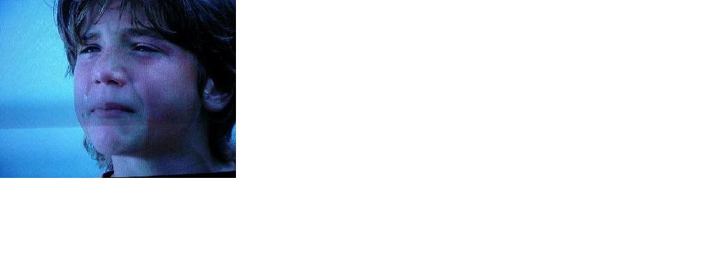

KV32HV600
Subject
Ghosting on progressive scan, HD.

SYMPTOMS
Ghosting on progressive scan, HD.
RESOLUTION
This is do to the compress signal from Satellite or DVD disc.
The affects of this high compression can be seen on all size TVs, however on 32 inch and above it becomes extremely noticeable, thus causing the most complaints.
1. The distortion is usually viewed as many small squares (tiling) instead of a clear picture, especially in areas that require a lot of detail (for example around the eyes).
2. Ghosting or halo effect around people (usually seen around the shoulders or heads of people). (DirecTV cause)
3. HD-100 was causing a red streak down a person's face.
4. Solid walls or wood grain walls that should be stationary have movement.
5. Also fast motion causes a similar artifact as number 1* (many small squares (tiling) instead of a clear picture).

Model KV32HV600: Features

FD TRINITRON PICTURE TUBE
HU-SCAN 1080I CHASSIS
DRC MULTIFUNCTION V1 (960I X 480P)
CINEMOTION REVERSE 3-2 PULLDOWN
FLEXIBLE TWIN-VIEW TWO TUNER PICTURE-AND-PICTURE
MID X (MULTI-IMAGE DRIVER X) CIRCUITRY
SCROLLING CHANNEL INDEX SYSTEM
MEMORY STICK MEDIA STILL IMAGE PLAYBACK
HD DETAILER WIDEBAND VIDEO AMP
CLEAREDGE VM WIDEBAND VELOCITY MODULATION
2 HD CAPABLE COMPONENT VIDEO INPUTS (Y/PB/PR)
720P INPUT CAPABLE(1080I CONVERSION)
3D DIGITAL COMB FILTER
AUTO 16:9 ENHANCED MODE
ID-1 DETECTION (480P)
TRUSURROUND SOUND (7.5W X 2)

Model KV32HV600: Specifications

DIMENSION | 35 3/8 X 27 1/8 X 24"
WEIGHT | 176 LBS 8 OZ
COMPONENT VIDEO | 2 READ HD
COMPOSITE INPUT | 3 REAR/1 FRONT
SVIDEO INPUT | 2 REAR/1 FRONT
RF INPUT | 2 REAR
ENERGY STAR COM | YES
MONITOR OUT | 1 REAR

