Project #1
Simple Meter probe
by
Dennis Viereck
Like many of you I've had my share of "Opp's' 's in my life. Like accidentally slipping off of a narrow surface mounted IC and short circuiting another pin, while using a fat clumsy meter probe. If your lucky and nothing goes up in smoke you escaped Murphy's Law, this time. But if your meter probe tip is the size of most meters probes you may not be so lucky the next time. This project is a simple one that reuses normal house hold items, A Simple pall point pin, a small sewing needle, and hot glue the create a meter probe that rivals any on the market today. With test lead wire and a banana plug you have the materials for a very versatile meter probe.
The materials needed are
- A ball point pen (non mechanical type)
- Small sewing needle 1.5 inches long
- Hot Glue and glue gun
- Test probe wire (could be from an old broken meter probe)
- Banana Plug (could be attached to the old broke meter probe wire)
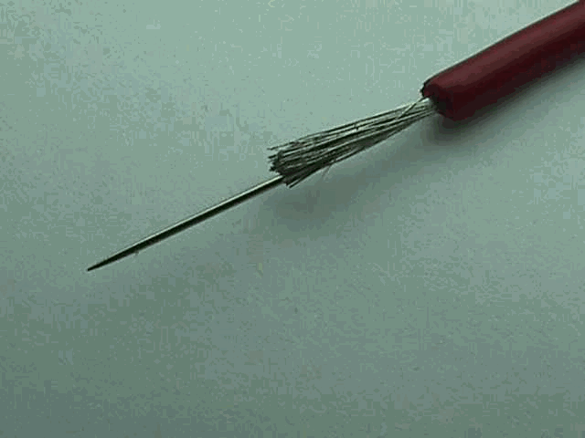
Preparing the test lead wire by cutting back about 1/2 inch of insulation. Do not tin the wire. Carefully work the eye of the needle into the end of the wire, deep enough to hold the needle secure.
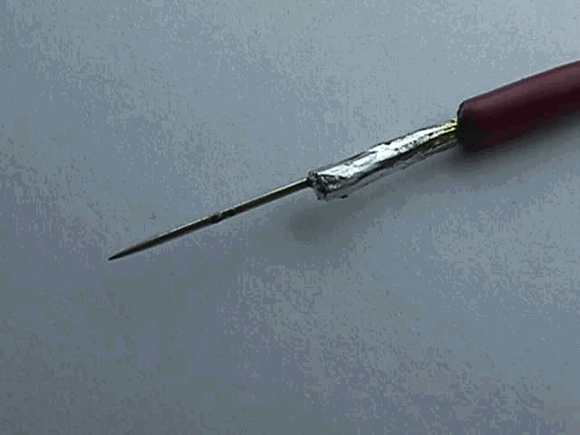
Solder the needle and wire together where all the stands of wire are covered in a solid flow of solder.
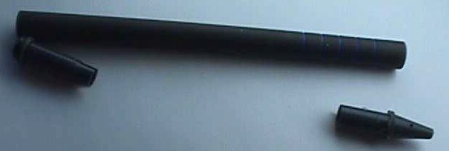
Disassemble the old ball-point pen. The brand of pen is not important but I suggest the pens that use the self-contained ink cartridge because it creates less of a mess. Remove and discard the old ink cartridge. Locate the pen tip as shown in the lower right corner of this picture.
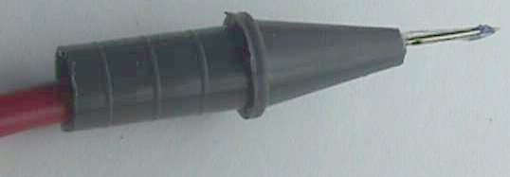
Fill the pen tip with a 3/8 inch drop of hot glue in the large opening and quickly insert the needle and wire into the large end of the pen tip. Allow only about 3/8 of an inch of the needle to protrude from the end as shown in Fig 5. Let the assembly cool down. Don't try to trim the excess glue until it cools. Insert the pen tip into the old ball point pen housing and shoot a small amount of hot glue into the rear of the probe to secure test lead wire.
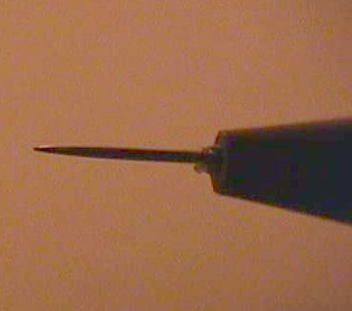
The actual needle tip is .027 inches diameter and the point is less than .004
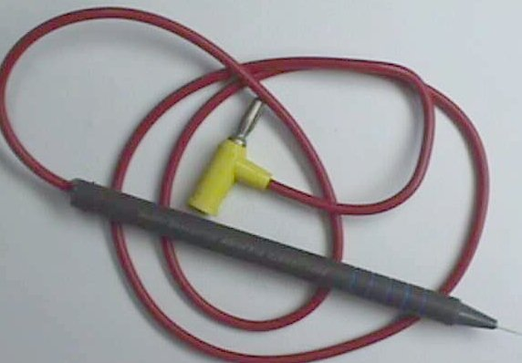
Ahhhhh. Finally finished. In very little time you will have a simple and effective probe that will run circles around most stock meters probes and best of all this probe can land on a single pin of a 120 pin flat pack IC without falling off.
Happy Probing
Dennis Viereck
wa6ati@mindspring.com

