Solar Power Converter

By

Ting-Hau Ho
David Kline
Jet-Sun Lin

ECE 345, SENIOR DESIGN PROJECT
FALL 2002

TA: Mark Wiegert

10 December 2002

Project No. 26

ABSTRACT

This project collected, stored, and converted solar energy into 120V_{ac} electrical power to drive a small appliance. The design consisted of a solar panel, step-down DC converter, battery, voltage monitor controller, and DC/AC inverter. The efficiency goal was 66%. Actual realized efficiency was 60.8%.

TABLE OF CONTENTS

- INTRODUCTION 1
1.1 Review and Update Material 1
1.2 Specifications 1
1.3 Subprojects 1
- DESIGN PROCEDURE 3
2.1 Design Decisions 3
2.2 Tools Used 6
- DESIGN DETAILS 7
3.1 Components 7
- DESIGN VERIFICATION 16
4.1 Stand-Alone Testing 16
4.2 Conclusions 18
- COST 19
5.1 Parts 19
5.2 Labor 19
- CONCLUSIONS 20
APPENDIX 21
REFERENCES 24

INTRODUCTION

This project aimed to create a completely self-contained unit capable of converting light energy from the sun into electrical energy, storing that energy chemically, for later use, in the form of a battery, and then converting the chemical potential energy back into electrical energy capable of driving a 120V_{ac} appliance. A voltage monitoring controller was added to prevent damage to the battery. The initial goal was to build a device that could be easily carried for the purposes of demonstrating the viability of solar power to various audiences. However, the converter should be easily adaptable and scalable for use in a variety of applications, including as a portable, renewable power source for field scientists, busy travelers, and even recreational uses such as camping or tailgating. Because it derives energy from the sun, it will also save the user money on energy costs.

  - Review and Update Material

During the design and building of the project, changes were made from the original proposal due to several factors, including availability of materials and cost restrictions. These included the use of a lower-power solar panel, a motorcycle lead-acid battery, the addition of a voltage monitoring controller circuit, and modification of the DC/AC inverter design.
These changes will be described in detail in sections 2 and 3 of this report.

  - Specifications

The most important specification was to achieve a 120V_{ac} output capable of driving a small appliance. In addition, an efficiency goal of 66% across the entire converter was desired. At each stage, there were specific input and output specifications based upon the parts available. These included the output from the solar panel of 22-24V_{dc}, the battery float charge voltage of 13.8V_{dc}, and nominal battery discharge voltage of 11-12V_{dc}. The designs of each section were based upon these ranges, and were tested over the entire range of expected values.
Efficiencies at each major stage were measured separately. Major contributors to loss of efficiency were duty cycle requirements in the PWM controller in the DC step-down converter, and safety margins (dead-time) required for safe operation of the MOSFETs in the DC/AC inverter.

  - Subprojects

The project consisted of five main stages, shown in Figure 1.1.

Voltage
Monitor
11 V

Solar
Panel
Solar
Converter
Battery
Appliance
(Desk Lamp)

DC to AC
Converter

Voltage
Monitor
13 V

Figure 1.1. Block Diagram of Major Project Components

- DESIGN PROCEDURE

The project design was divided into three major components: the solar panel and DC step-down converter, the voltage monitoring controller, and the DC/AC inverter. Primary responsibility for the design, implementation, and testing of these sections fell to each of the three team members, although all team members helped with all sections at various times. The team members’ primary responsibilities were: Jet Lin – solar panel and DC step-down converter, Ting-Hau Ho – Voltage Monitoring Controller, and David Kline – DC/AC inverter.

2.1 Design Decisions

Solar Panel/DC Step Down Converter
The major design decisions were made based upon availability of the components. The solar panel was the limiting factor in these decisions due to cost. Originally, a BP Solar bp sx 30 panel was specified in the proposal. This panel turned out to be quite costly ( > $200) and therefore, other options were pursued. Eventually, Professor Krein of the ECE Power Lab was generous enough to lend us a solar panel. The output specifications were thus amended to reflect the smaller amount of power available from this solar panel.
The DC step-down converter was originally based upon a Maxim MAX830 chip, but in the final project a MAX724 was used. This was due mainly to pin-out considerations, as the MAX830 chip was a mini-SO design which did not work well in the breadboard. Either a time-consuming custom PC board would have had to have been built, or a risky, inaccurate manual soldering of wires to the chip would have to be performed. Instead, we opted to use another chip with a TO-220 package, and the added bonus of being able to handle more current. The MAX724 package was able to provide more current (5A vs. 2A) than the MAX830 while being easier to use in the breadboard.

Voltage Monitoring Controller
For the voltage monitoring circuit, it was observed that the voltage across the battery terminals actually increases as it is charging, even when supplied with an otherwise constant voltage source, such as the output from the DC step-down converter (see Fig. 2.1). The battery is charging until the switch is turned ON. As shown, the voltage across the terminals is changing as a function of time. This voltage change is the result of the chemistry inside the battery (see Appendix 1). Therefore, it was possible to monitor the voltage while charging the battery directly.
Fig. 2.1. Battery characteristic (charging and discharging with load)

Originally the voltage monitoring circuit was designed with a Maxim MAX8216 chip. Because of the cost and availability of the MAX8216, it was decided instead to design an op-amp based solution using the LM741 chip to implement the voltage monitoring circuit [1]. A Zener diode was originally placed at the output of the battery in an attempt to obtain a constant voltage reference against which the actual voltage across the terminals would be compared. However, this solution proved unfeasible as the diode was unable to handle the current out of the battery. Instead, the reference voltage was obtained by inserting an MC7812 voltage regulator chip at the output of the solar panel. This would provide a constant 12V output for any input voltage greater than 12.8V. Since the solar panel was always operating above 20V in sunlight, this would be acceptable.
Other approaches to the battery monitor were to measure the current and/or the temperature of the battery as it was charging. These would have been difficult to directly measure, and thus it was decided to monitor the voltage across the terminals instead.
Because of the high current requirements of the output from the battery, relay switches were needed as the switching part of the voltage controller instead of ordinary logic gates.

DC/AC Inverter
We designed the inverter to utilize a full bridge MOSFET configuration driven by a pulse width modulated (PWM) signal. The PWM process approximates a low-frequency sine wave by adjusting the duty ratio of a fast square wave. The square wave is generated by comparing a modulating waveform to a carrier waveform. The comparator provides a high output when the modulating signal is greater than the carrier signal, and provides a low output otherwise. The output of the comparator is used to provide the necessary switching signals to our MOSFET bridge.
A full bridge inverter consists of four MOSFETs arranged as in Figure 2.2 that work together to provide either a positive or negative voltage to the load. The peak voltage of a full bridge inverter is equal to the DC source battery voltage. In our circuit, the battery is allowed to have voltages of 11 to 13 volts. In theory, this will provide an RMS output voltage of 7.8 to 9.2V.

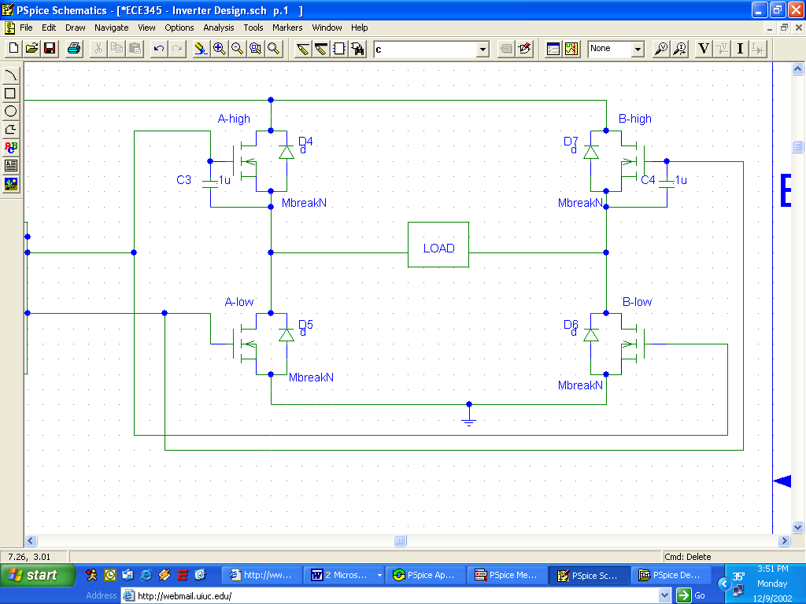
Figure 2.2. MOSFET full bridge inverter

The key to operating the inverter is to control the MOSFETs in such a way that current is never allowed to flow through both MOSFETs on the same leg. This would result in a near short-circuit from the battery to ground, with the only resistance being the small internal resistance of the MOSFET. This would allow a very high “shoot-through” current to flow directly to ground and damage the MOSFETs. Therefore, as long as we control the inverter so that one ‘A’ MOSFET and one ‘B’ MOSFET off at all times, we will not experience a shoot-through current since the current will always be forced to go through the load.
We attempted to use a transformer to step up our AC output voltage to 120V_{ac, rms}. However, we quickly realized that the transformers available to us in the ECE parts shop did not have a high enough current capacity required to achieve our desired output. Our ideal transformer would have a 6.5:120 turns ratio and a current capability of 19A on the primary (low side) of the transformer. The closest match in the parts shop was a 10:117 transformer with a current limit of 4A. When we attempted to use this transformer, we could a achieve a 110V_{ac, rms} output voltage on the secondary side with no load. When we attempted to drive a load using the transformer the voltage on the primary side remained constant at 6.4V_{ac, rms}, but the voltage on the secondary side dropped to 0.4V_{ac, rms}. This suggested to us that our transformer was inadequate. We determined it was not vital to our project to obtain a transformer that would function correctly since this would be a simple addition in the future.

2.2 Tools Used

In the design procedure, PSpice was utilized to make schematics of the circuits involved. However, because of the limitations on simulations for power circuits, the simulation functions were not utilized.

DESIGN DETAILS

This chapter will describe, in detail, the actual final design of the project. Like the previous chapter, the design will be separated into the three major components and each design will be detailed separately. Also, how each of the components was linked to the other two is described.

3.1 Components

Solar Panel/DC Step-down converter
The solar panel provided to us by Professor Krein was tested in sunlight, and determined to provide, on average, a 24V output at 300mA in afternoon sunlight. The output from the solar panel was stepped down through the converter shown in Fig. 3.1 to a level of 13.8V. This level is actually adjustable by varying the ratio of R1 and R2. For the actual build, a 15kΩ turnpot was used in place of R1 so that fine adjustments could be made in the output level. The Maxim chip is a PWM controlled switch-mode regulator [2], which is far more efficient than using a voltage divider or resistive network to regulate the voltage.

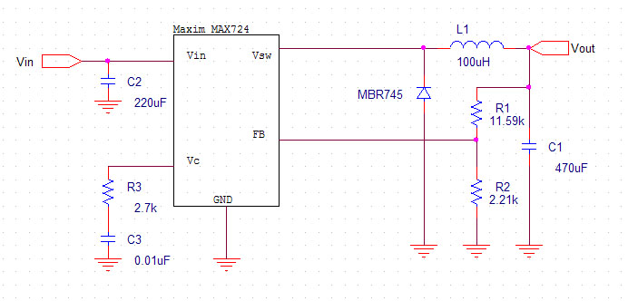
Figure 3.1. DC Step-down converter schematic

The output level is governed by the following equation (from the Maxim specification sheet)
$R_{1}=\frac{V_{\text{OUT}}R_{2}}{2\text{.}\text{21}V}−R_{2}$ (3.1)
2.21V is the reference voltage at FB designed into the Maxim chip, thus choosing R₂ at 2.21kΩ ensured a 1mA flow through the leg, and simplifies the equation. Thus, R₁ is theoretically set at 11.59kΩ. In practice, the turnpot was simply adjusted such that the output voltage was as close to 13.8V as possible.

Voltage Monitoring Controller
The voltage controller consists of two independent voltage monitor circuits with two relay switches.
Figs. 3.2 and 3.3 show the final voltage monitor design. Figs. 3.4 through 3.7 show the characteristics of the relay switch, and how the voltage monitor circuit is connected with the relay switch.

Figure 3.2. 11V voltage monitor

Figure 3.3. 13V voltage monitor

V
V

9.8 V

3.3 V

Time
Time

Switch
Switch

Fig. 3.4. Characteristic of the relay switch (W60HE1S-12DC).

Ground
Output of
Monitor A
Battery

DC/AC
Converter

Fig. 3.5. Relay switch (W60HE1S-12DC).

V
V
Time
7.0 V
Switch
Time
3.1 V
Switch

Fig. 3.6. Characteristic of the relay switch (W60HE2S-12DC).

Solar
Converter

Output of
Monitor B
Battery

Ground
Ground

Fig. 3.7. Relay switch (W60HE2S-12DC).

The following equations refer to Fig. 3.2.

Vin(at pin #2) = V3 [R2/(R1+R2)] (3.2)

Vin(at pin #3) = V1 [R5/(R4+R5)] (3.3)

To have Vout(at pin #6) > 0:
Vin(at pin #3) > Vin(at pin #2) (3.4)

Substitute V1(desired) = 12 V, Eqs. (1), and (2) into Eqs. (3) yields
12 [R5/(R4+R5)] > V3 [R2/(R1+R2)] (3.5)
When Vin(at pin #2) < 0.5*V1
Vout(at pin #6) = Vin(at pin #7) - Vin(at pin #4) (3.6)

DC/AC Inverter
The inverter design is further subcategorized into its respective components, each of which is described below.

Precision Waveform Generator Design (Intersil ICL8038)
We used an Intersil ICL8038CCPD chip to generate the 60Hz sine wave required for comparison to the triangle waveform. This circuit was chosen due to its flexibility, simplicity, and availability in the ECE parts shop. The circuit design is shown in Fig. 3.8.
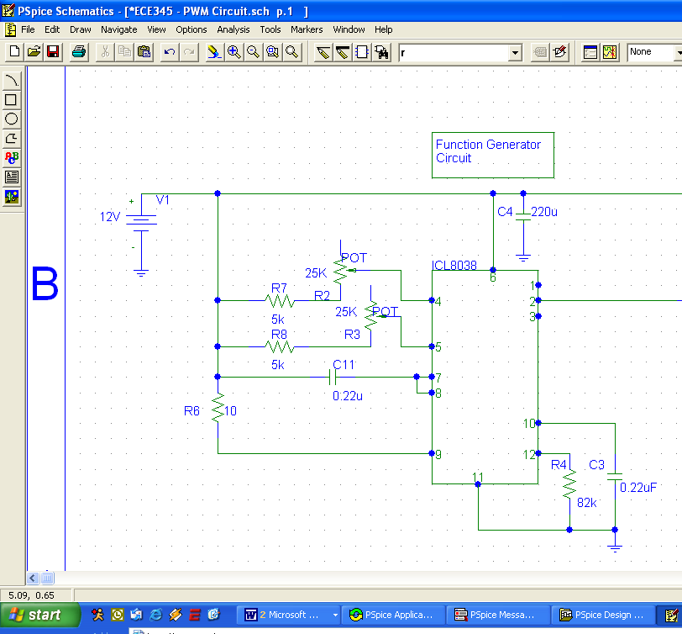
Figure 3.8. ICL8038 Circuit Design

The frequency of the ICL8038 can be controlled by external resistors and capacitors attached to the circuit and sized as specified by the datasheet for the chip. If the resistances on pins 4 and 5 are the same, the frequency can be controlled by the following equation provided by the datasheet.
f = 0.33/(R*C) (3.7)
Therefore, using a 22uF capacitor, a 25kΩ resistor is required on each pin. To ensure that both resistors are exactly identical, we used a 25kΩ potentiometer in series with a 5kΩ resistor and tuned each potentiometer until each pin had an equivalent resistance of exactly 25kΩ. However, this yielded a frequency of 62.6Hz, most likely because our capacitor has an accuracy of only 20%. Thus, the actual resistance required to achieve a 60.0Hz sine wave was 24.746kΩ.
Tests on the output signal revealed that the average and peak-to-peak output voltages of the sine wave were dependent on the input voltage to the chip. The results of these tests are summarized in Table 3.1.

Table 3.1. ICL8038 Output Voltage Characteristics
Vin | Vp-p | % of Input Voltage | Vavg | % of Input Voltage
9 | 2.125 | 23.61 | 4.4685 | 49.65
9.5 | 2.187 | 23.02 | 4.7185 | 49.67
10 | 2.312 | 23.12 | 4.969 | 49.69
10.5 | 2.437 | 23.21 | 5.2185 | 49.70
11 | 2.532 | 23.02 | 5.453 | 49.57
11.5 | 2.656 | 23.10 | 5.703 | 49.59
12 | 2.781 | 23.18 | 5.9845 | 49.87
12.5 | 2.875 | 23.00 | 6.2185 | 49.75
13 | 3 | 23.08 | 6.469 | 49.76

DC Coupling Circuit
For proper comparison against the SG3525 triangle waveform, the average output voltage must be set to 1.5V under all inputs and have a maximum peak-to-peak output voltage of 3V. Therefore, we used a coupling circuit to eliminate the DC bias from the ICL8038 before the SG3525 input. This circuit is shown in Fig 3.9.

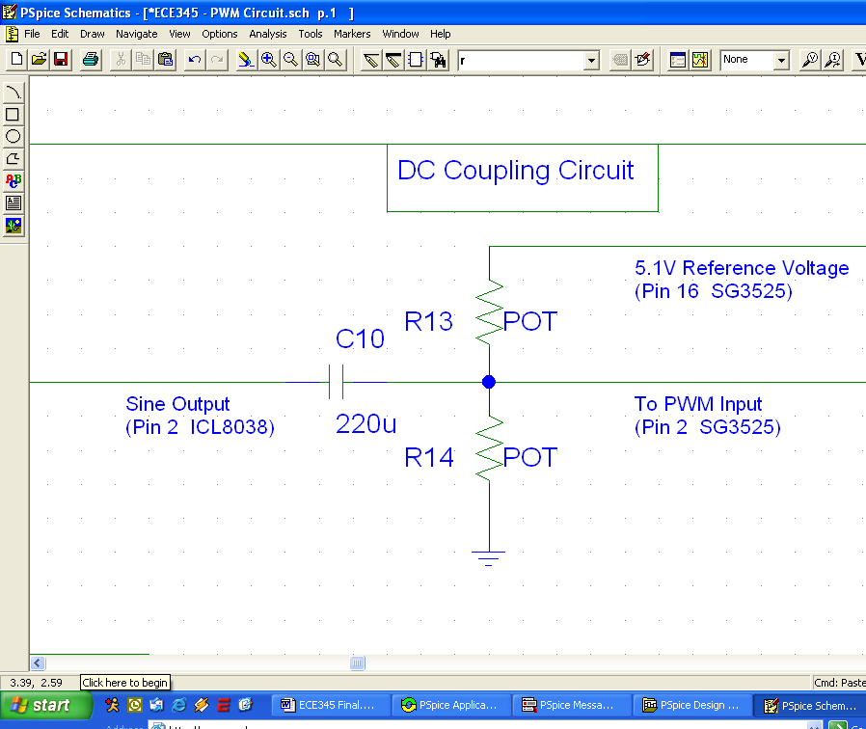
Figure 3.9. DC Coupling Circuit

To eliminate the DC bias on the ICL8038 output, we used a coupling capacitor of 220μF. It was then necessary to add a 1.5V DC bias, which was accomplished by using a 5kΩ potentiometer and the 5.1V reference voltage from the SG3525. The following voltage divider can be used to set the DC bias voltage.
V_{bias} = 5.1*( R₁₄/(5kΩ- R₁₄)) (3.8)
By setting the proper resistances in the voltage divider, a 1.5V DC bias was added to the signal. These resistances were R₁₃=3.864kΩ and R₁₄=1.136kΩ.
Since the peak-to-peak voltage of the signal was less than 3V under all allowed input voltages, no alteration was necessary to the peak-to-peak voltage.

PWM/Comparator Design (LS SG3525)
The PWM/comparator we chose was an LS SG3525. This chip had many advantages, including an internal sawtooth triangle waveform generator, dead time adjustment, and dual outputs suitable for controlling switches. Additionally, it was available in the ECE parts shop. The circuit design is shown in Fig. 3.10.
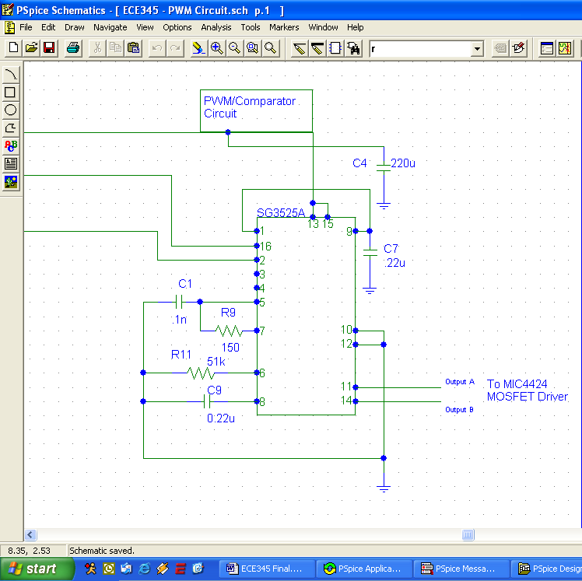
Figure 3.10. SG3525 circuit design.

The datasheet on the SG3525 provides very little information on the values required to set the frequency of the triangle waveform other than the minimum and maximum frequencies. Therefore, we set the timing capacitor between the limits at 1μF and experimented with the timing resistor to try and achieve a triangle waveform frequency of 60kHz. We settled on a resistance of 51kΩ which yielded a frequency of 75kHz.
One issue that arose was that the rapid switching signals generated by the chip caused a ripple voltage to occur on the voltage supply to the entire system. This ripple caused the ICL8038 to malfunction and quit generating its sinusoidal signal. This was resolved by adding a 220μF capacitor on each supply voltage bus on the protoboard. This controlled the ripple voltage enough so that all the chips operated properly.
The SG3535 also included a control for the dead time between switching signals. The dead time was controlled by a resistor between pins 5 and 7. Again, the SG3525 gave minimum and maximum values for this resistance, ranging from 0 to 500Ω. After experimenting with different values for the dead time resistor, we settled on a 150Ω resistance, which gave us 120ns of dead time between switching signals. This was almost twice as much as the 72ns switching time of the MOSFETs and would prevent a shoot-through current from occurring under any circumstances.

Full Bridge Inverter Design
The PWM output signals were used to drive a full bridge inverter consisting of four MTP52N06 MOSFETs arranged as shown in Fig. 3.11.
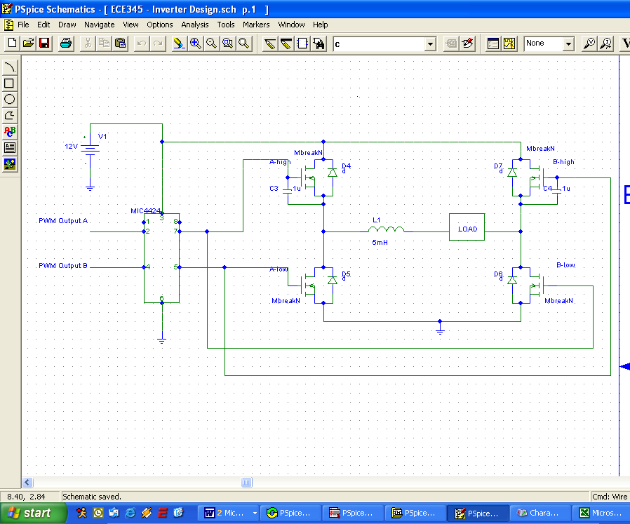
Figure 3.11. Full Bridge Inverter Design

These MOSFETs were chosen due to their high current capability of 52A and high reverse voltage blocking ability of 60V. These characteristics are much greater than required by our design. Additionally, these MOSFETs included an internal reverse polarity diode, so an external diode was not required. These MOSFETs also have a low drain-to-source resistance of 0.024Ω.
We quickly determined that the SG3525 would not be able to drive our MOSFETs, and that amplification of the output signal would be necessary. We chose to use a Micreal MIC4424 MOSFET driver that was available in the ECE parts shop. The addition of this driver allowed us to provide our switching signals to the MOSFETS without loading down the SG3525.
We also determined that the switching signals were not consistently of a high enough voltage for long enough to drive the high-side MOSFETs on each leg. This was resolved by placing a small 0.1μF capacitor between the gate and source pins on each high-side MOSFET. This capacitance served to support the switching signal driving each gate and allowed the MOSFET to operate properly.

4. DESIGN VERIFICATION

Each section was first built and tested in a stand-alone fashion before it was introduced into the rest of the project. Again, the results of each section will be described independently in 4.1, and then the testing of the project as a whole will be discussed in 4.2.

4.1 Stand-Alone Section Testing

Solar Panel and DC Step-Down Converter
The solar panel output was measured under bright sunlight with a handheld HP DMM. Voltage was 22.2V, and the short circuit current was 300mA. From the Solar Constant, 1300W/m², and the surface area of our panel, 0.2m², the incident energy upon the solar panel was 260W. Given the measured voltage and current, the output from the solar panel was actually only 6.66W. This represents an efficiency of 2.56%.
The range of voltages for which a steady 13.8V output could be maintained was an important metric by which the success of this section could be measured. Although the solar panel could be expected to maintain a steady output of 22-24V in bright sunlight, there could be other times when the sun could be obscured or other less-than-perfect conditions arise that would provide a lower voltage. Thus, measurements were taken in lab conditions using the HP6632A power supply in the lab, and resulting outputs were measured using the Fluke DMM. Results are presented graphically in Figure 4.1.

Figure 4.1. Voltage output over range of inputs

From 14.25V up past the 20V maximum of the HP6632A, the output voltage was a steady 13.8V. This shows that the step-down converter was able to provide a good output over the entire range of expected inputs.
The efficiency of the converter was 76%, based upon the input power of 6.66W from the solar panel, and a 13.77V output at 368mA, yielding 5.07W. Most importantly, the output from the converter was able to charge the battery.

Voltage Monitoring Controller
For Fig. 3.2: Vout(at pin #6) = 11.35 V when V3 < 10.99 V This condition will cause the relay switch to disconnect DC/AC converter from voltage monitor A (11 V voltage monitor)(see Fig. 3.5).
For Fig. 3.2: Vout(at pin #6) = 3.36 V when V3 >= 10.99 V This condition will cause the relay switch to connect DC/AC converter with voltage monitor A (11 V voltage monitor)(see Fig. 3.5).

For Fig. 3.3: Vout(at pin #6) = 11.35 V when V3 < 12.98 V This condition will cause the relay switch to connect solar converter with voltage monitor B (13 V voltage monitor)(see Fig. 3.7).
For Fig. 3.3: Vout(at pin #6) = 3.09 V when V3 >= 12.98 V This condition will cause the relay switch to disconnect solar converter from voltage monitor B (13 V voltage monitor)(see Fig. 3.7).

From the above tests, the precision of the voltage monitor circuit is 0.01 V.

DC/AC Inverter
We examined the output power delivered by the inverter using a 12V DC power supply to eliminate changes caused by the discharging of the battery. This should give us an output voltage of 8.4Vrms. We obtained a real output voltage of 6.4Vrms due to voltage drops caused by the MOSFETs and other losses in the system. We used high-power resistors to test the circuit, and the efficiency results are summarized in Figure 4.2
Figure 4.2. Inverter Efficiency

The Inverter was able to maintain 80% efficiency for a wide range of loads.

4.2 Conclusions—The Project as a Whole

Although it was not possible to drive an actual 120V appliance due to the transformer limitations, it was encouraging to get a true 120V alternating current output, verified by the DMM. Because of the inability for the final stage to drive a meaningful load, it was not possible to measure an overall efficiency of the entire project from beginning to end. Instead, the individual stages were measured for their efficiency, and when considered together, the DC step-down converter and DC/AC inverter represented an overall efficiency of 60.8%. This is only a little short of the original goal of 66% efficiency.
The voltage monitoring controller performed as expected during simulated charging and discharging cycles, protecting the battery from overcharging and from being overdrawn during the discharge phase.

5. COST

Because of the generosity of the ECE Parts Shop and Maxim Electronics, along with Professor Krein of the ECE Power Lab, the actual parts cost was minimal. The total cost of the project including labor at the rate given in the proposal was $11.260. This is considerably under budget. The parts and labor costs are detailed below.

5.1 Parts

The only parts cost involved was the purchase and shipping of an Intersil H-Bridge FET driver which was not actually used in the final circuit. This chip cost $11 to obtain. All other parts were loaned or donated by the respective parties involved.

5.2 Labor

The labor cost involved 3 engineers working on average 6 hours per week. At the rate given in the proposal, this turns out to be
$$\frac{\$\text{25}}{\text{engineer}×\text{hour}}×2\text{.}5×\frac{6\text{hours}}{\text{week}}×\text{10}\text{weeks}×3\text{engineers}=\$\text{11}\text{.}\text{250}$$

6. CONCLUSIONS

Although the project was not able to drive the final load, a detailed analysis of each section was done, and actual values were close to the expected values all the way up to the transformer. We believe that a more suitable transformer would solve the final problem, which should not be a difficult solution. However, because of time and cost constraints, a more suitable transformer could not be located prior to the deadline.
The project also involved a lot of redesign and adjustment of specifications due to the availably and/or cost of parts. Although the final design consisted of a relatively small solar panel, the circuit could easily accommodate the panel originally specified in the proposal, probably with better power results.
In future projects, the transformer can be specified earlier in the design process to allow more time for verification and testing. Also, the efficiency should be improved upon by adjusting PWM duty cycles and dead-time as much as possible while still maintaining a safety margin for the MOSFETs.

APPENDIX 1.

The lead-acid battery chemistry allows for a direct monitoring of voltage as the charging cycle happens. This section details some of the chemistry behind how this happens and why we were able to use this to our advantage. (Reprinted from http://hyperphysics.phy-astr.gsu.edu/hbase/electric/leadacid.html [4])

Lead-Acid Battery  Batteries use a chemical reaction to do work on charge and produce a voltage between their output terminals.  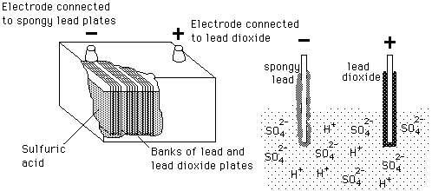 | Index  DC Circuits  Batteries
  Chemical reaction | Charging | Discharging
HyperPhysics***** Electricity and Magnetism | Go Back

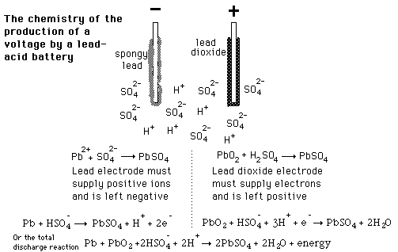 | Index  DC Circuits  Batteries
  Lead-acid batteries
HyperPhysics***** Electricity and Magnetism | Go Back

Lead-Acid Battery  The reaction of lead and lead oxide with the sulfuric acid electrolyte produces a voltage. The supplying of energy to and external resistance discharges the battery.  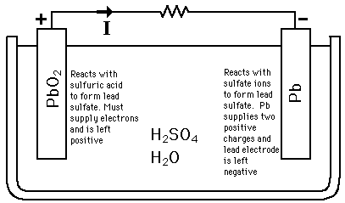 | Index  DC Circuits  Batteries
  Lead-acid batteries
HyperPhysics***** Electricity and Magnetism | Go Back

Charging the Lead-Acid Battery  The discharge reaction can be reversed by applying a voltage from a charging source.  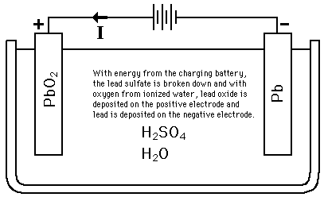 | Index  DC Circuits  Batteries
  Lead-acid batteries
HyperPhysics***** Electricity and Magnetism | Go Back

REFERENCES

[1] van Roon, Tony, “741 Op-Amp Tutorial”,
http://www.uoguelph.ca/~antoon/gadgets/741/741.html
[2] Dallas Semiconductor/Maxim Corporation , “Maxim DC-DC Converter Tutorial”, http://www.maxim-ic.com/appnotes.cfm/appnote_number/710
[3] Krein, Philip T., Elements of Power Electronics. New York. Oxford University Press, Inc., 1998, pp. 206-229.
[4] Georgia State University Physics Dept., “Lead-Acid Batteries”, http://hyperphysics.phy-astr.gsu.edu/ hbase/electric/leadacid.html

