Some Ideas for Connected Cars and Self-Driving Cars
May 29th, 2017
DM Fraser

Tail Gating and Rear End Collisions

All new cars starting in 2018, I believe, are required to have back up cameras. And the images have superimposed grids to indicate distances.

These cameras could be used to enhance safety and aid in accident investigations.

Crash Investigation
For many years the air bag controller in cars have recorded various items of information to aid crash investigators. Generally for the previous 5 seconds, data which is constantly overwritten with new data until deployment.

An easy to add feature to aid in crash investigation, mainly just software and a small storage capacity increase with present technology would be for the backup camera to record the rear view when the vehicle comes to a stop and the engine is still running or the car is in gear, without turning on the in dash display. With say 30 seconds of video recorded with it being overwritten until the car starts to move again or the engine is shut off. Overwriting would turn off if the air bag controller detects an impact.

Tailgating
In a current technology car, the user could have the option of manually actuating the rear view camera to record tailgaters or aggressive drivers. The recording would include vehicle speed direction and if possible GPS coordinates. Then if they want to save that video for downloading to a USB drive for sending to law enforcement. To protect privacy, the tailgater could be warned by having the vehicle flash its center brake light while recording.

Of course, in states where front licence plates are not required, I would expect that front plates would entirely disappear.

In a Connected car, the driver would have the same setup but an option to transmit the video to law enforcement. Additional data would to for the car to try to connect to the tail gating vehicle and if it is a connected vehicle, could read that vehicle’s ID code recording it in an encrypted form only readable by law enforcement. Law enforcement would deal with the information according to whatever statutes the state has passed. The writer suggests that the vehicle owner is emailed or mailed a warning the first several times before a summons is issued. But that would be up to the authorities in each state.

Failing that, possibly to a shaming web site for general amusement.

In a Self/Assisted Driving Car, the recording would start automatically whenever the car detected vehicles following too closely. Again with warning from the center brake light to give the offender a chance to correct their driving. If the tailgating vehicle backs off, the recording would stop and the recording erased.

Self Driving Cars
One hazard I see with self driving cars is that they would likely be programmed to only go as fast as the posted speed limits and no faster. Assuming the USA or Canada for an example, on multi lane roadways they should be programmed to remain in the farthest right lane possible that allows them to maintain the posted speed limit if possible. Where slowing is preferred to lane changing unless the speed differential is excessive and the next left lane is at or below the speed limit. It is likely that this is already being programmed into the control computers of self driving cars as the concept is obvious.

The particular hazard of note is tail gating by drivers who want to speed and it is not possible for the self driving car to move to the right. In which case they need to be warned that the car ahead of them is not going to go any faster because you cannot intimidate a computer.

Here it is suggested that some of the LEDs in the center mounted brake light change color when a car is in self driving mode. Or even when a car has its cruise control engaged.

This can be done as the cost of individually addressable LEDs that can shine in any color has become very reasonable. It is quite feasible to tell every other LED in the center brake light to shine blue when in self driving or cruise mode. When brakes are applied, all the LEDs can then switch back to red as required.

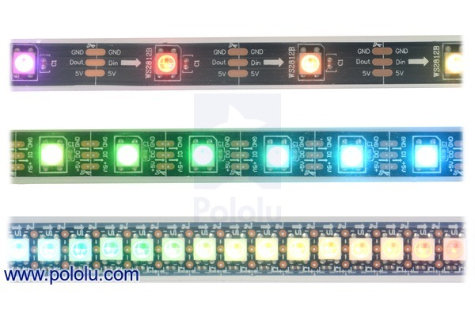
A search for “addressable multicolour LEDs” gives many hits such as:
https://www.pololu.com/category/20/leds

A car’s engine or chassis control module can contain the intelligence to drive them

These LEDS can be any color and can change from one to another very rapidly or as slowly as one might wish. The strips illustrated can be cut to any length and pretty well any LED spacing desired is possible.
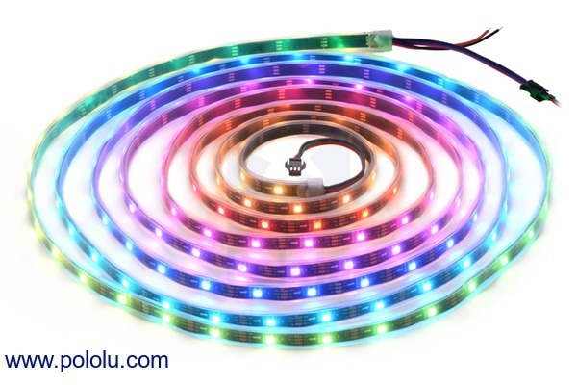
They could even sequence from right to left or left to light to be an added signal light or anything an automotive designer may imagine.

By doing this with the rear mounted brake light, there would be no need to mandate any new housing or anything that would affect styling that is not being done already.

PEDESTRIAN ASSURANCE
For general pedestrian assurance there could also be a light in the agreed color, maybe blue, inside the grille of the self driving car but visible in daylight so pedestrians can see that the vehicle is self driving. So if a pedestrian has safety concerns they can see whether an approaching vehicle is in self driving mode and they can take whatever precautions they feel is necessary. Or maybe with an LED strip like these, the light pattern could even move back and forth when the car detects pedestrians nearby like a robotic Cylon’s eyes in Battlestar Galactica

